**Armold: Humanoid Robotic Arm**

**Sponsor:** Rose-Hulman

**NDA Status:** No NDA

| Dylan Dorman,  Engineering Design  Mechanical Engineering | Andi Fiani, Engineering Design  Materials Science | Shelby Schipper, Engineering Design  Entrepreneurship | Chris Steiner,  Computer Science  Art |
| --- | --- | --- | --- |

1. **Problem Summary**

The purpose of this project is to examine the real-world applications and benefits that a humanoid robotic arm could yield, particularly in manufacturing. Armold is a proof-of-concept version of this robot which was designed and fabricated from scratch within the 2023-2024 school year. He will remain at Rose-Hulman indefinitely as a fun, interactive display. The goal of Armold is to show future students what they are capable of creating by applying their engineering skills.

Armold’s range of motion is comparable to that of a human arm. Users control the robotic arm with a wireless control panel that accepts inputs from both sensors and a touchscreen. The touchscreen GUI enables the operator to select from a variety of functionalities, including operating Armold live-time, recording a new motion, and replaying a motion (once or on a loop).

The combination of ease of use, versatility, and adaptability is what sets Armold apart. Another advantage of Armold is that he is controllable via analog inputs. This means a user can quickly create a new motion by manipulating a physical control panel rather than changing code. The controls are labeled with the parts of the arm that they govern such that the control panel is user-friendly.

1. **ABET Design Criteria**

**2.1 Requirements**

| **No.** | **Requirement** | **Importance to system** |
| --- | --- | --- |
| 1 | Armold’s purpose and explanation of his system(s) must be accessible when the system is used. | Important for prospective/new students (a key stakeholder) to see Armold's purpose and functions such that they are inspired to pursue projects that apply engineering skills. |
| 2 | The project must be entirely standalone; the operation of Armold may not be tied to an individual on the team or require a laptop. | Armold is a stay-behind display which means he must be operable once his creators have graduated. |
| 3 | The length of the arm from the top of the shoulder to the tip of the middle finger must be less than 28” long. | Important for Armold to resemble a human arm and so he clears the 80/20 stand base. |
| 4 | Armold should resemble and move like a human arm. This does not extend to realism in terms of appearance. | Important for users to easily visualize motions the arm needs to undergo for the desired process outcome. |
| 5 | All actuators will be capable of a set range of motion:   * crossbody: ≥ 45 +/- 5 degrees * frontal raise: ≥ 200 +/- 5 degrees * lateral raise: ≥ 90 +/- 5 degrees * elbow: ≥ 135 +/- 5 degrees * pronation: ≥ 180 +/- 5 degrees * fingers: open/closed positions | Important for the mechanical system of Armold to closely replicate motions the human arm can make. |
| 6 | Armold will be able to perform preset motions. (Waving hello, dancing, other movements) | Important to have a demonstration for users as to how Armold can record, save, and replay motions. |
| 7 | Armold can lift 1 lb. | Designing conservatively for full functional operation, and so he can hold and pour paint (a goal of the project). |
| 8 | Armold will have signage explaining operation and safety precautions. | Important to reference safety standards and describe expected operations to prevent any potential damage. |
| 9 | Armold must have an E-stop (on the arm’s electronic system). | Important for the safety of all stakeholders. |
| 10 | The touch screen on the control panel will provide clear options for the user. | Ease of use is important so Armold has a faster changeover time between operations (and is therefore more adaptable). |

**2.2 Detailed Design**

Armold is a complex system made primarily of 3D-printed parts, all of which have been designed by the team.

**Shoulder:** The shoulder is made of 3 actuators. The lateral raise and cross-body motions are actuated by servo motors. The frontal raise motion is the only one on Armold that is powered by a stepper motor since this motion requires the most torque. Each actuator utilizes a custom-designed gearbox.

**Elbow/Forearm:** One servo motor powers the bending of the elbow and another powers Armold’s pronation.

**Hand:** With elastic and fishing line strings running through each finger, a powerful micro servo facilitates the motion of each finger individually.

**Wiring:** With 10 motors total, proper organization of Armold’s wiring system was crucial. The wires run up the arm and down the stand to the base where the power supplies and microcontrollers are located. A voltage regulator chip is used for each servo motor to step down voltage but still enable the motors to meet high current demands. The stepper motor is driven by its own power supply and motor driver.

**Brain:** Armold's brain (control

panel → robot) consists of a system that uses two Raspberry Pis and two Arduino Megas. There is one of each on both the control panel and the robotic arm. The Pis are used for wireless communication and better computational handling. The Arduinos are used for analog input/output handling. When the Arduino in the control panel receives inputs from the user, it sends these inputs to the control panel Raspberry Pi via serial communication. The control panel Pi maps the values before sending them to the Pi on Armold, which then uses serial communication to get these values to Armold’s Arduino. As a result, Armold moves to the desired position.

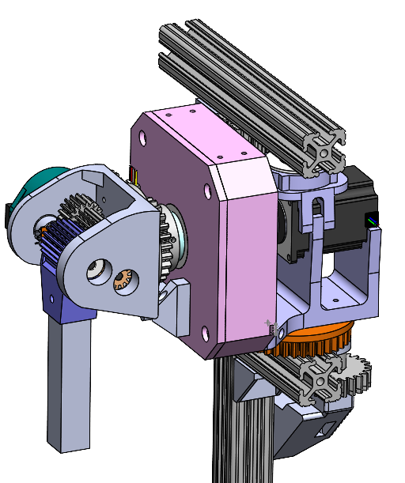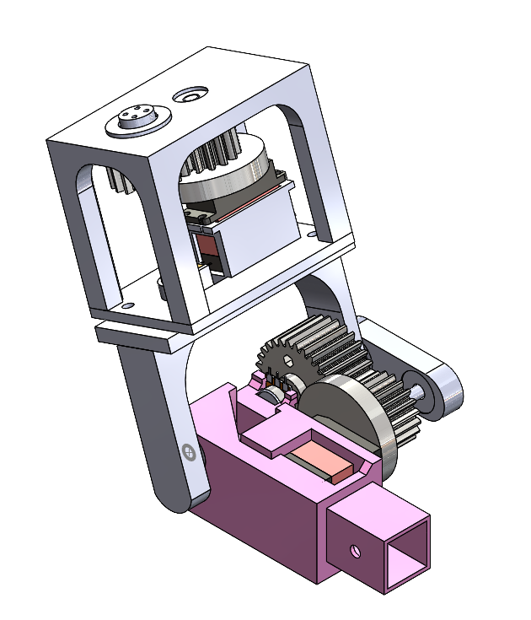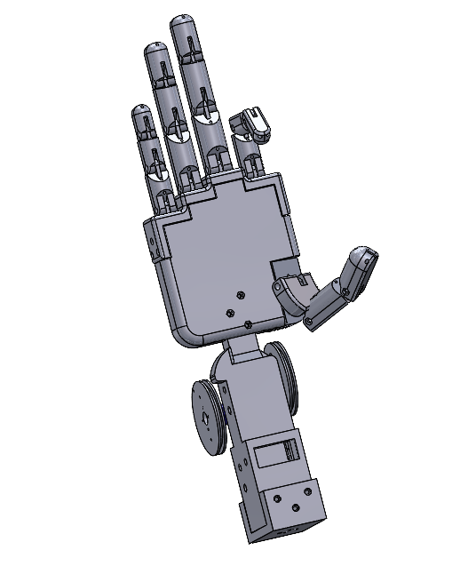

**2.3 Prototype Details**

* Armold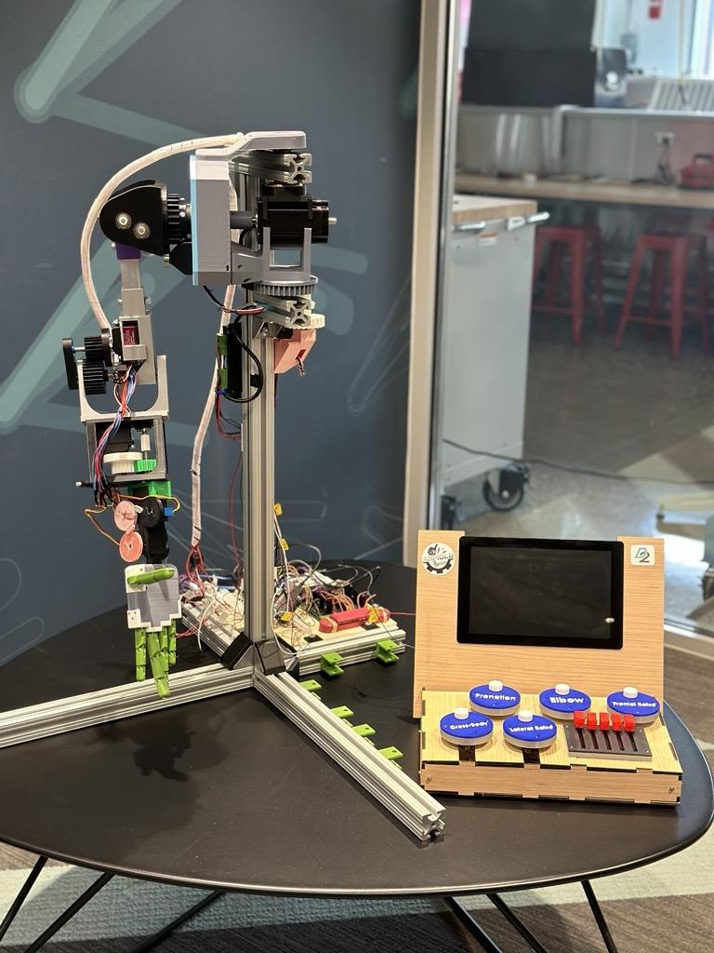
  + Constructed mostly from 3D-printed PLA parts
    - Many of these are assembled using metal hardware (screws, bearings)
  + The frame is 80/20 aluminum extrusion
  + Powering actuators require a 12V, 15A (servos) and a 24V (stepper) power supply
* Control panel
  + Housing is laser-cut plywood
  + Controls are designed for ease and enjoyment of use
  + Touch screen GUI for clear guidance of operations and more functionality

**2.4 Evidence**

| **Rec No.** | **Result** |
| --- | --- |
| 1 | This document will be displayed alongside Armold: [Armold's Purpose](https://docs.google.com/document/d/1nFc_5uyBm7Z6QHiX8FrEijE-kSiO12ptUJFtSmq3Ft0/edit?usp=sharing) |
| 2 | The arm establishes an SSH connection between the control panel and the arm with the Rose-Hulman server. No laptop is required to communicate tasks between devices. |
| 3 | Measured arm length: 27.5”. |
| 4 | The average human arm proportions are 38.6% for the upper arm, 34.4% for the forearm, and 27% for the hand. The arm measures with the upper arm at 35%, 36% for the forearm, and 29% for the hand, meaning there is <5% difference in each section of the robotic arm from the average human arm. |
| 5 | The ROM for each actuator was tested and moved the following amount:   * crossbody: 45 degrees * frontal raise: 200 degrees * lateral raise: 80 degrees * elbow: 90 degrees * pronation: 175 degrees * fingers: open/closed positions |
| 6 | The GUI allows users to play recorded motions that were created by another user. It also allows them to record motions themselves which can be named and added to a list of actions. |
| 7 | With all motors powered correctly, the arm can lift 1 lb of weight when the arm is fully extended. |
| 8 | An engraved sign is displayed alongside Armold and will be mounted to the enclosure that is decided upon by Rose-Hulman. This sign includes basic instructions on how to safely operate Armold and precautions to avoid hurting themselves or damaging the machine. |
| 9 | The E-stop can be pressed at any time and connects to the power supplies controlling the arm. |
| 10 | The GUI has buttons labeled “Debug”, “Live Control”, “Record Movement” and has symbols to represent shutting the system down, playing a motion, stopping a motion, or looping a motion. |

1. **Design Checklist:**

| Public Health, Safety, and Welfare | Armold operates within a range of 5’ x 4’ x 5’ and should be kept inside an enclosure of this size in his final display location, which will be decided on by Rose-Hulman staff. An emergency stop has also been added in case of emergencies. |
| --- | --- |
| Global Factors | The robotic arm and stand are fully modeled in CAD. A wiring diagram will be created for the next users to be able to understand the electrical engineering of the arm. |
| Cultural Factors/ Social Factors | The target audiences for Armold are incoming students, current students, and current staff. The project is designed to serve as a fun, interactive way to encourage members of the Rose-Hulman to pursue passion projects that apply engineering skills. |
| Environmental Factors | 3D-prints consisting of PLA and TPU that were broken or unusable during the construction and testing processes were recycled on Rose-Hulman’s campus. |
| Economic Factors | The budget for this project was limited to $1000. 3D-printed and metal parts were fabricated in-house to reduce costs and waiting times. |

1. **ABET Problem Solving Criteria:**

**Problem:**

It was necessary to determine which servo motor and gears would be necessary to lift the weight of the arm at each joint. If servo motors that do not provide the required torque are used, the weight of the arm could cause them to stall or even rotate backward. The elbow joint had to be analyzed before the team could select an appropriate motor with a stall torque high enough that Armold could meet his functional requirements.

**Summary:**

The first step to solving this problem was to estimate how much weight the elbow needed to support. A requirement is that Armold should be able to hold a 1lb weight in his hand and weigh less than 5 lbs total. Assuming the arm is designed according to these requirements, we created a simple sketch to represent the elbow-to-hand section with associated forces.

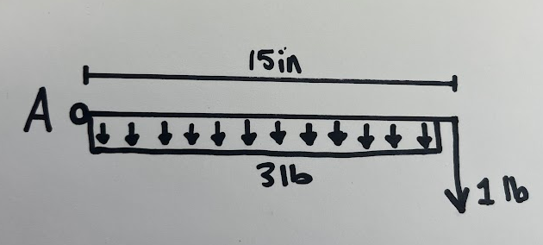

A distributed load was used to model the assumption that the forearm and hand of the system weigh 3 pounds. Point A represents the pivot point of the elbow. The moment exerted on the elbow is found in the following calculations. The motors the team planned to purchase presented stall torque in Kg*cm. As such, our computation units were converted accordingly.

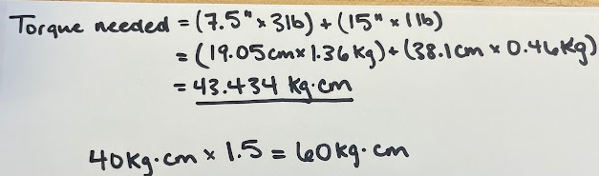

The “Torque needed” (torque necessary to support the loading of the model above) was found to be 43.434 Kg*cm. This presented a dilemma as the largest servo motor available was a 40 Kg*cm servo. To ensure that the elbow could support the weight, a gear ratio of 1.5 was utilized. The introduction of the gear ratio meant that the elbow, when powered correctly (with maximum operating voltage to the servo) could support a total torque load of 60 Kg*cm. This solution met requirements and provided a load factor of safety of 1.38 on the elbow.

A downside of adding gears is that it reduces the elbow’s range of motion. With a gear ratio of 1.5, the 270-degree range of motion that the 40 Kg*cm servo motor outputs is reduced to 150 degrees. Thankfully, 150 degrees is still greater than the required range of motion for the elbow, which was planned to be 135 degrees.